Vote for your favorite Dr. Seuss Book!

1. Place a check in the box next to the books you read.
2. Circle the one you like best.
3. Write to tell why you chose your book.

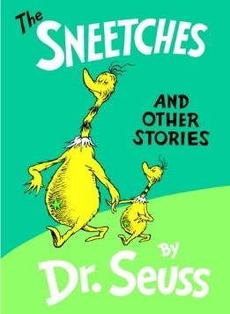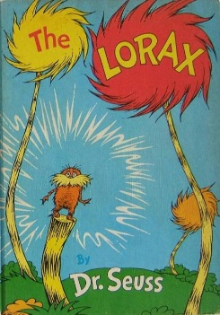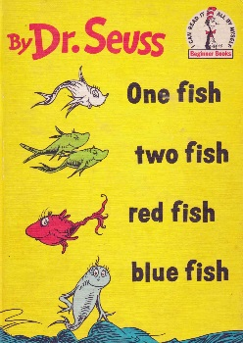[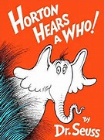](http://www.bing.com/images/search?view=detailV2&ccid=XG5BcPDh&id=E719B7BF72E6910BF51B3910834129697E70A3AC&q=horton+hears+a+who+book&simid=608028909315293350&selectedIndex=0)

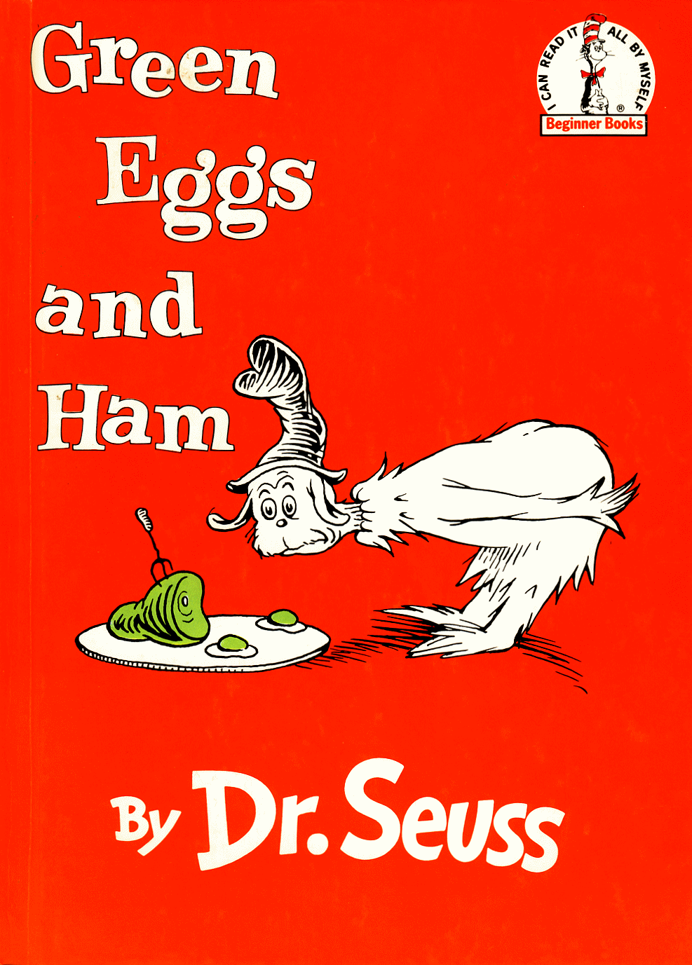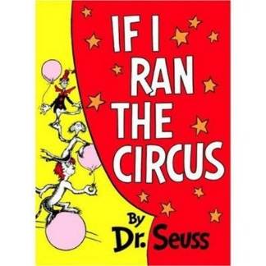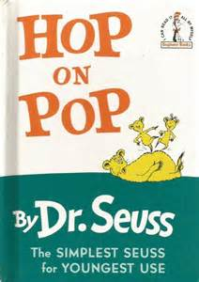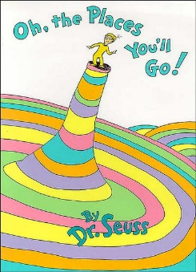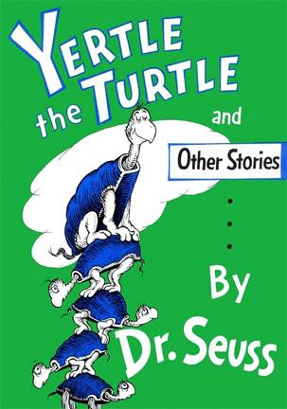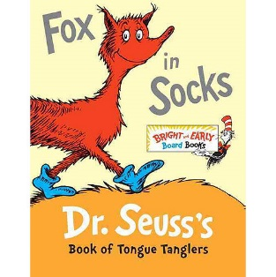

Name: _______________________ Grade: ______

My favorite Dr. Seuss book is:

_________________________________________

Because ______________________________________

____________________________________________________________________________________________