Think About This
To think that it once used to be
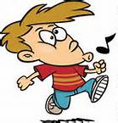
Oh so very simple
To pucker up my lips and blow
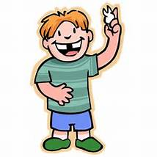
And make a big loud whistle.
Then three little baby teeth
All tumbled from my mouth.
Now I pucker up and blow
But not a sound comes out!

********************************************************************************************
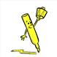
Highlight the words with the th sound.
Write the words below.

th- –th
at the beginning of the word at the end of the word

______________________ ______________________
______________________ ______________________
______________________ ______________________
______________________ ______________________

