[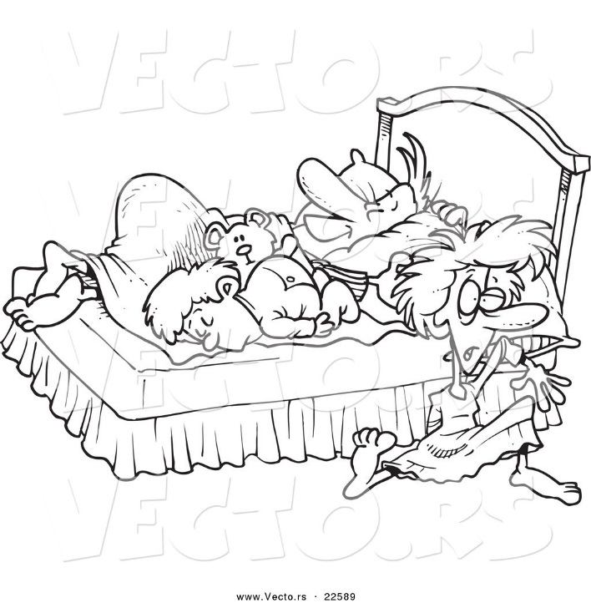](http://www.google.com/url?sa=i&rct=j&q=&esrc=s&frm=1&source=images&cd=&cad=rja&uact=8&ved=0CAcQjRw&url=http%3A%2F%2Fvecto.rs%2Fdesigns%2Fcrowded-bed&ei=OQj6VJsqzJU289GDiA4&bvm=bv.87611401,d.eXY&psig=AFQjCNGwiQi-l7DETkYfl4IMGKkhZJYlFQ&ust=1425758400759041)There were five in the bed *(Hold up five fingers)*And the little one said, “Roll over, roll over!” *(Make rolling motion)*So they are rolled over and one fell out.

(*Hold up one finger & surprised face)  
*** Count down until*There was one in the bed *(Hold up one finger)*And the little one said, “I’ve got it all to myself!”

*(Spread out arms)*