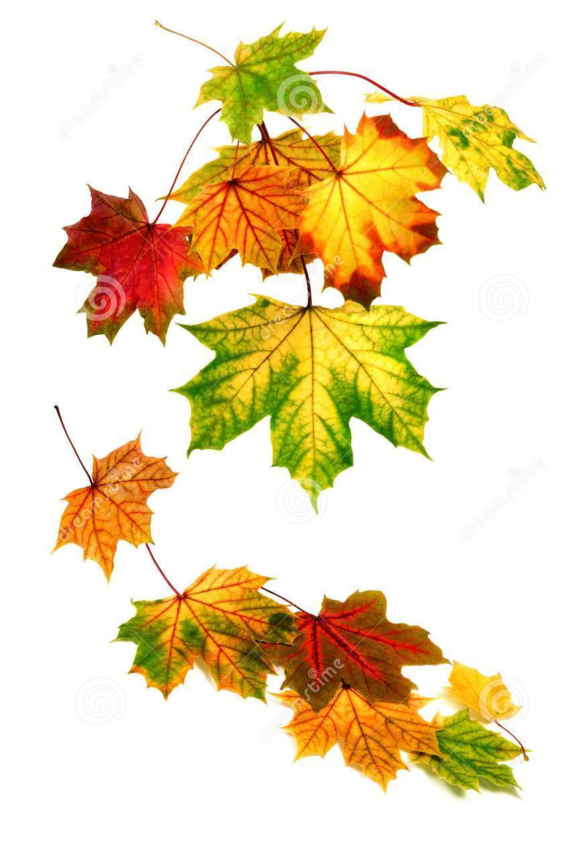
A Thank You Note To Fall
By: Patricia Hubbell
Leaves,
like
brilliant
birds
that flutter,
Wind,
that plays
with door
and shutter,
School,
and friends
both old and new,
Football,
Soccer,
(turkeys, too,)
Pumpkins,
apples,
geese in V’s,
Icy lace
where
puddles
freeze,
Thank you Fall,
for all
of
these!

