[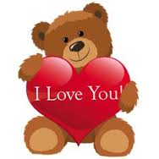](http://www.google.com/imgres?imgurl=https://s-media-cache-ak0.pinimg.com/236x/01/8a/16/018a163e0cc26fffd8ba19f1e7da8e1a.jpg&imgrefurl=https://www.pinterest.com/twigster1954/teddy-bear-tags-and-printables/&h=236&w=236&tbnid=15h1b3Y3tV5gnM:&zoom=1&docid=0LJVY_8125WgcM&ei=jgn6VL7GPImUNpXzgNAD&tbm=isch&ved=0CGcQMygqMCo)Teddy bear, teddy bear, reach up high  
Teddy bear, teddy bear, touch the sky

Teddy bear, teddy bear, turn around  
Teddy bear, teddy bear, touch the ground  
  
Teddy bear, teddy bear, touch your knees  
Teddy bear, teddy bear, sit down please