[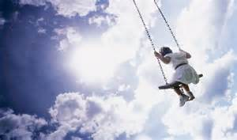](http://www.bing.com/images/search?q=images+children+swinging&view=detailv2&&id=49885C3379811C9DB8617BD79C0573BEC9D258F6&selectedIndex=42&ccid=SIVBxkfe&simid=607998758132125038&thid=OIP.M488541c647de3a6c90822a64480a579fo0)

**In the Playground**

**By: Abiodun Oyewole**

**In the playground of my dreams where the sun beams**

**and I seem to be**

**whatever I want to be**

**I am free**

**away from the clouds all day**

**In the playground of my dreams**

[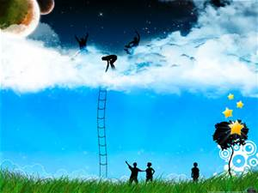](http://www.bing.com/images/search?q=images+kids+dreams&view=detailv2&&id=6957C51B9A98C2129C5D2B918ABE1F6E4927CA9C&selectedIndex=181&ccid=ytl7Yxax&simid=608016814190627319&thid=OIP.Mcad97b6316b130f52f90a5a02e6f942cH0)

[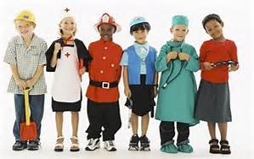](http://www.bing.com/images/search?q=images+children%27s+dreams&view=detailv2&&id=977A99AEBCEDAE729A23AC77FF74CDED544DDB49&selectedIndex=114&ccid=wmothWar&simid=607995042993409428&thid=OIP.Mc26a2d8566abd67671d1a4021be38cb7o0)[](http://www.bing.com/images/search?q=images+kids+dreams&view=detailv2&&id=29A892754E1C812E18BB132558D3AA0548B683BF&selectedIndex=183&ccid=Np28WChZ&simid=608027611733754869&thid=OIP.M369dbc582859ef97139e7b56275b1d2ao0)[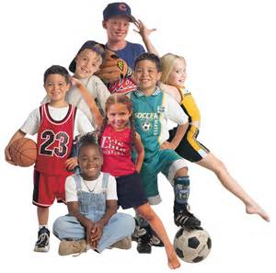](http://www.bing.com/images/search?q=kids+sports+images&view=detailv2&&id=09F585AB888882B20D896EC98FBCB5C1CE9DB00C&selectedIndex=57&ccid=rW%2btVkw1&simid=607997778887706742&thid=OIP.Mad6fad564c35f5493251930032e248e7o0)[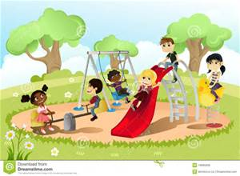](http://www.bing.com/images/search?q=images+kid+playground+cartoons&view=detailv2&qpvt=images+kid+playground+cartoons&id=D9E32AFF6DFBE40AAB3BB7C9CA87FA6483046E18&selectedIndex=16&ccid=wg4l4%2fWy&simid=608042420777058715&thid=OIP.Mc20e25e3f5b22313e978a74613fbaf41H0)[](http://www.bing.com/images/search?q=images+children%27s+dreams&view=detailv2&&id=3C837C525BB25A912C754ED8785326535AF1275B&selectedIndex=39&ccid=%2byVfiaHT&simid=607990374368217077&thid=OIP.Mfb255f89a1d348aab982dd0665a42042o0)