FALL : The Mist and All
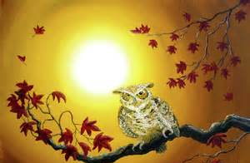
By: Dixie Willson
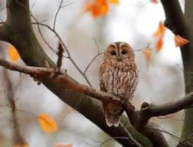
I like the fall,
The mist and all.
I like the night owl’s
Lonely call—
And wailing sound
Of wind around.

I like the gray
November day,
And bare, dead boughs
That coldly sway

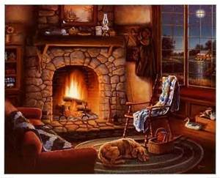
Against my pane.

I like the rain.
I like to sit
And laugh at it—
And tend
My cozy fire a bit.
I like the fall—
The mist and all.

